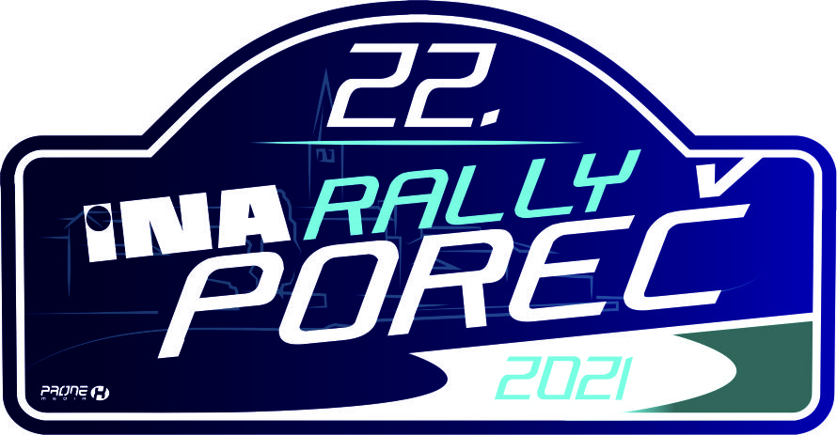
ACCREDITATION FORM FOR JOURNALIST

Name and Surname
Editorial office
Newspaper |  | Radio |  |  | Internet |  |  |  | TV
Journalist |  |  | Fhotoreporter |  |  |  | Kameraman
Address
Phone / Mobile
Fax
E-mail
Web site

RALLY HQ, AUTOMOBILE CLUB ”POREČ MOTORSPORT” POREČ
HQ: Partizanska 5A,HR-52 440 Poreč
Tel: +385 95 368 86 30,Edi Milokanović
Internet address: http://rally-porec.eu

RALLY PRESS CENTER
Adress: TBA
Office hours: 01.10.2021. from 12:00 till 20:00
02.10.2021. from 07:30 till 21:00
E-mail: pressrallyporec@gmail.com

Advance payment for press marker in the amount of :

Place and date: |  | Signature:

By signing this form, I agree to participate in the competition in my own risk!

